1. Creating and Renaming Files/Directories Create a directory named test_dir using mkdir. Inside test_dir, create an empty file called example.txt. Rename example.txt to renamed_example.txt using mv
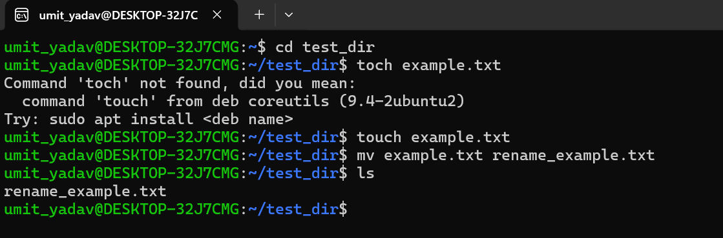
Command:-
- mkdir test_dir
- cd test_dir
- touch example.txt
- mv example.txt renamed_example.txt
Explanation:-
- mkdir test_dir ->Creates a directory named test_dir
- cd test_dir -> Enters the directory
- touch example.txt -> Creates an empty file
- mv example.txt renamed_example.txt -> Renames the file
2. Viewing File Contents Use cat to display the contents of /etc/passwd. Display only the first 5 lines of /etc/passwd using head. Display only the last 5 lines of /etc/passwd using tail.
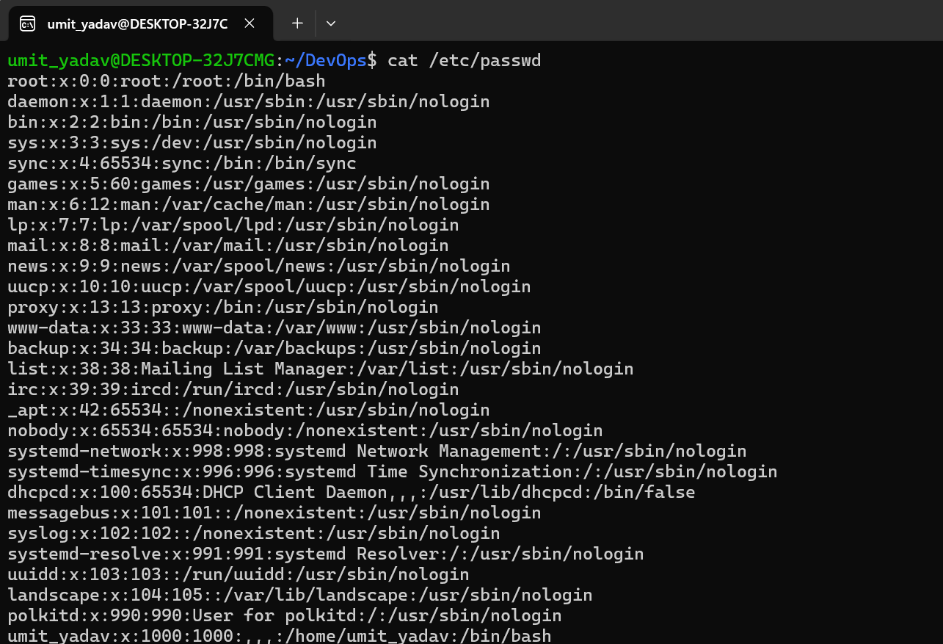
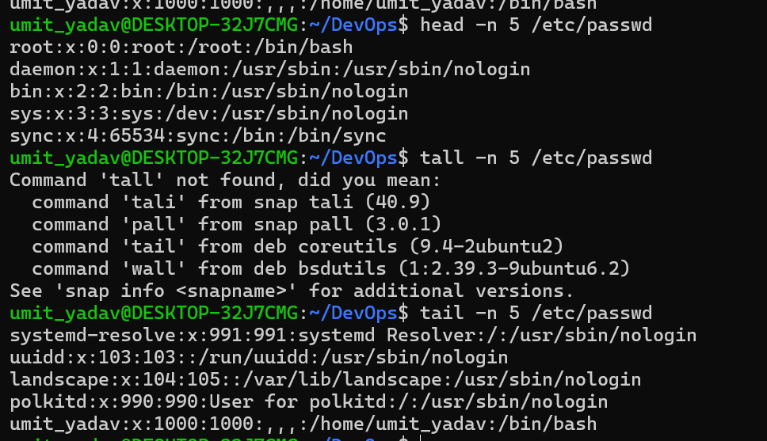
Command:-
- cat /etc/passwd
- head -n 5 /etc/passwd
- tail -n 5 /etc/passwd
Explanation:
- cat ->Shows complete file content
- head -n 5 -> Shows first 5 lines
- tail -n 5 -> Shows last 5 lines

3.Searching for Patterns Use grep to find all lines containing the word "root" in /etc/passwd.
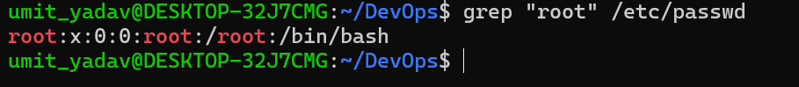
Command:-
- grep "root" /etc/passwd
Explanation:-
- grep searches for lines containing root
- /etc/passwd contains system user information

4. Zipping and Unzipping Compress the test_dir directory into a file named test_dir.zip using zip. Unzip test_dir.zip into a new directory named unzipped_dir.
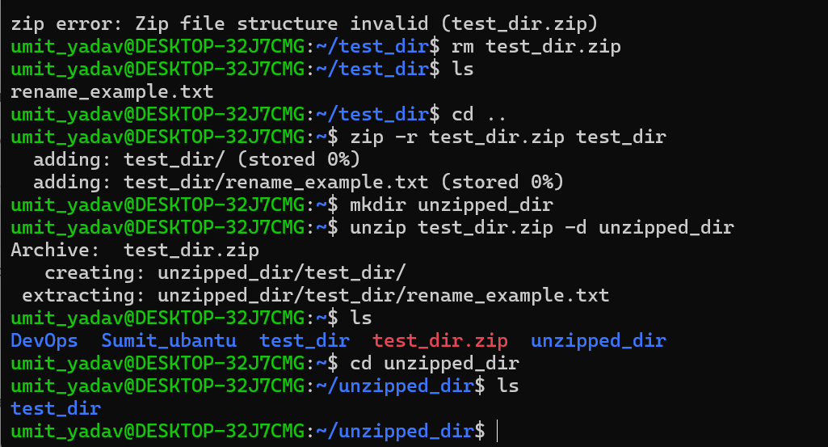
Commands:-
- zip -r test_dir.zip test_dir
- mkdir unzipped_dir
- unzip test_dir.zip -d unzipped_dir
Explanation:-
- zip -r → Compresses directory recursively
- unzip -d → Extracts files into specified directory

5. Downloading Files Use wget to download a file from a URL (https://free-apis.github.io/#/browse)
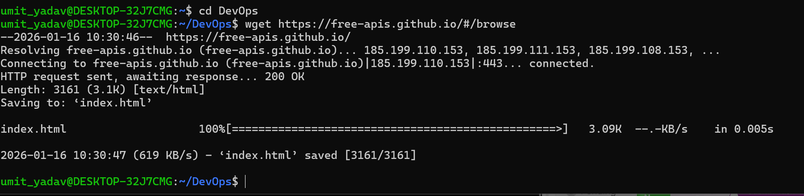
Commands:-
- wget https://example.com/sample.txt

Explanation:
- wget downloads files from the internet
- File is saved in the current directory

6 Changing Permissions Create a file named secure.txt and change its permissions to read-only for everyone using chmod.
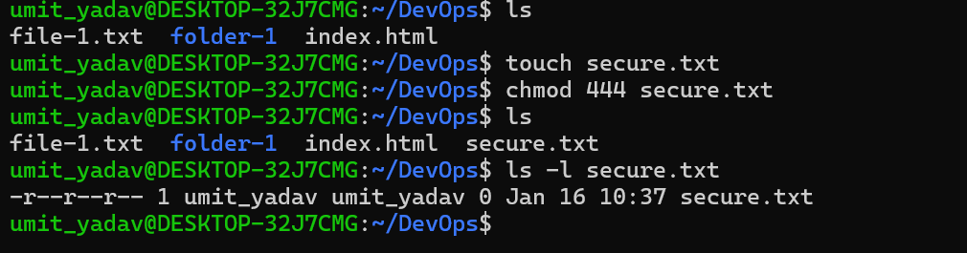

7 Working with Environment Variables Use export to set a new environment variable called MY_VAR with the value "Hello, Linux!".
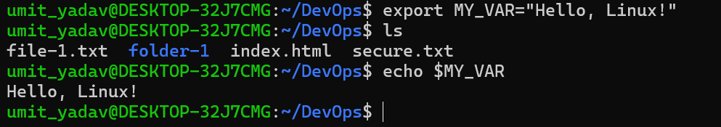
Commands:-
- export MY_VAR="Hello, Linux!"
- echo $MY_VAR
Explanation:
- export sets an environment variable
- echo $MY_VAR displays its value

